1.Draw a simple network diagram showing two routers connected over a WAN link and label where authentication is needed to prevent unauthorized access.

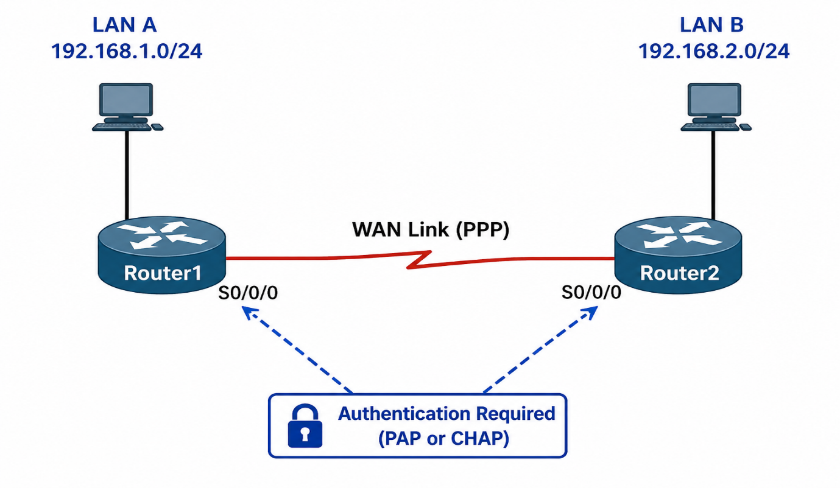
authentication is needed:
- Authentication verifies the identity of routers.
- Prevents unauthorized devices from connecting to the WAN.
- Protects network resources from unauthorized access.

2. Configure a sample HDLC WAN connection between two routers using Packet Tracer or any network simulator, and explain why HDLC does not provide authentication.<br><br><em><strong>Hint:</strong> Focus on the commands used and what is missing in terms of security.</em>
HDLC WAN Configuration Between Two Routers
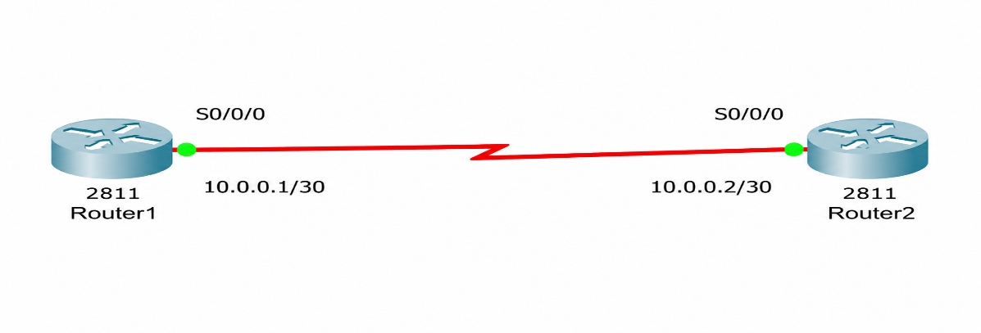
Network Topology
Router1 ---------------- Router2
S0/0/0 S0/0/0
10.0.0.1/30 10.0.0.2/30

Router1 Configuration
enable
configure terminal
interface serial 0/0/0
ip address 10.0.0.1 255.255.255.252
encapsulation hdlc
no shutdown
end
write memory

Router2 Configuration
enable
configure terminal
interface serial 0/0/0
ip address 10.0.0.2 255.255.255.252
encapsulation hdlc
no shutdown
end
write memory

Verification Commands
Check whether the link is working: show ip interface brief
Test connectivity:
ping 10.0.0.2
(from Router1)
ping 10.0.0.1
(from Router2)
If the pings are successful, the HDLC WAN connection is working correctly.
Why HDLC Does Not Provide Authentication
HDLC (High-Level Data Link Control) is a Layer 2 WAN encapsulation protocol used to transmit data between routers. While it efficiently encapsulates data, it does not include any authentication mechanism.
Notice the configuration commands:
encapsulation hdlc
There are no commands for usernames, passwords, or authentication protocols. Any router configured with compatible HDLC settings can establish a connection on the link.
Missing Security Features
- No username verification
- No password verification
- No identity checking of connected devices
- No protection against unauthorized routers joining the WAN link
Because of these limitations, HDLC is considered less secure than protocols such as PPP (Point-to-Point Protocol), which supports authentication methods like:
- PAP (Password Authentication Protocol)
- CHAP (Challenge Handshake Authentication Protocol)

3. Set up a PPP connection between two routers in Packet Tracer and enable PAP (Password Authentication Protocol) authentication. Show the configuration commands and explain what happens if the password is incorrect.

PPP Connection with PAP Authentication Between Two Routers
Network Topology
Router1 ---------------- Router2
S0/0/0 S0/0/0
10.0.0.1/30 10.0.0.2/30
PPP + PAP Authentication
Router1 Configuration
enable
configure terminal
hostname Router1
username Router2 password cisco123
interface serial 0/0/0
ip address 10.0.0.1 255.255.255.252
encapsulation ppp
ppp authentication pap
no shutdown
exit

Router2 Configuration
enable
configure terminal
hostname Router2
username Router1 password cisco123
interface serial 0/0/0
ip address 10.0.0.2 255.255.255.252
encapsulation ppp
ppp pap sent-username Router2 password cisco123
no shutdown
exit
Verification Commands
Check PPP status: show interfaces serial 0/0/0
Check authentication: show running-config
Test connectivity: ping 10.0.0.2
Expected Result:
Success rate is 100 percent (5/5)
How PAP Authentication Works
- Router2 sends its username and password to Router1.
- Router1 compares the received credentials with its local username database.
- If the credentials match, authentication succeeds.
- The PPP link becomes active and data transmission begins.

What Happens If the Password Is Incorrect?
Suppose Router2 is configured with:
ppp pap sent-username Router2 password wrongpass
while Router1 expects:
username Router2 password cisco123
Result
- Authentication fails.
- PPP session is not established.
- Routers cannot exchange data.
- Ping requests fail.
- Serial interface may show:
4.Modify your PPP configuration to use CHAP (Challenge Handshake Authentication Protocol) instead of PAP, and describe one key difference in how CHAP improves security over PAP.

To transition the point-to-point link from PAP to CHAP (Challenge Handshake Authentication Protocol), we must configure local usernames matching the hostname of the remote router and switch the authentication command on the interface.
Router1 Configuration
Plaintext
Router1> enable
Router1# configure terminal
Router1(config)# hostname Router1
Router1(config)# username Router2 password cisco123
Router1(config)# interface serial 0/0/0
Router1(config-if)# ip address 10.0.0.1 255.255.255.252
Router1(config-if)# encapsulation ppp
Router1(config-if)# ppp authentication chap
Router1(config-if)# no shutdown
Router1(config-if)# end
Router1# copy running-config startup-config
Router2 Configuration
Plaintext
Router2> enable
Router2# configure terminal
Router2(config)# hostname Router2
Router2(config)# username Router1 password cisco123
Router2(config)# interface serial 0/0/0
Router2(config-if)# ip address 10.0.0.2 255.255.255.252
Router2(config-if)# encapsulation ppp
Router2(config-if)# ppp authentication chap
Router2(config-if)# no shutdown
Router2(config-if)# end
Router2# copy running-config startup-config

Verification Commands
To verify that the configuration is working successfully and the link is up, use the following troubleshooting commands:
- show interfaces serial 0/0/0: Check that the line protocol is up (e.g., Serial0/0/0 is up, line protocol is up (encapsulation PPP)).
- show running-config: Verify that ppp authentication chap is active and passwords match.
- ping 10.0.0.2 (from Router1): Confirms end-to-end layer 3 connectivity over the authenticated link.

Key Security Difference: CHAP vs. PAP
Feature | PAP (Password Authentication Protocol) | CHAP (Challenge Handshake Authentication Protocol)
Password Transmission | Sends the password in plain text across the link. | Never sends the password over the network.
Mechanism | Simple two-way handshake (Username/Password sent, Accept/Reject returned). | Three-way Challenge-Response handshake using an MD5 hashed value.
Frequency | Authenticates only once during the initial link establishment. | Repeatedly re-authenticates the remote device at random intervals during the session.
5.Research and list two real-world scenarios (such as public WiFi login or mobile data authentication) where WAN authentication protocols like PAP, CHAP, or MS-CHAP are used, and explain why authentication is critical in each case.
- Public WiFi Login (Hotels, Airports, Cafes)
When users connect to a public WiFi network, authentication is often required before internet access is granted. Protocols such as PAP, CHAP, or MS-CHAP may be used by the network equipment to verify the user's credentials.
Why Authentication Is Critical:
- Prevents unauthorized users from accessing the network.
- Protects network resources and bandwidth.
- Helps track user activity for security and management purposes.
- Reduces the risk of cyberattacks from unknown devices.
- Mobile Data Authentication (4G/5G Networks)
Mobile service providers authenticate smartphones before allowing them to access mobile data services. Authentication protocols verify that the user has a valid SIM card and subscription.
Why Authentication Is Critical:
- Ensures that only authorized subscribers can use the network.
- Prevents fraud and unauthorized access.
- Protects customer data and billing information.
- Maintains the security and reliability of the mobile network.

